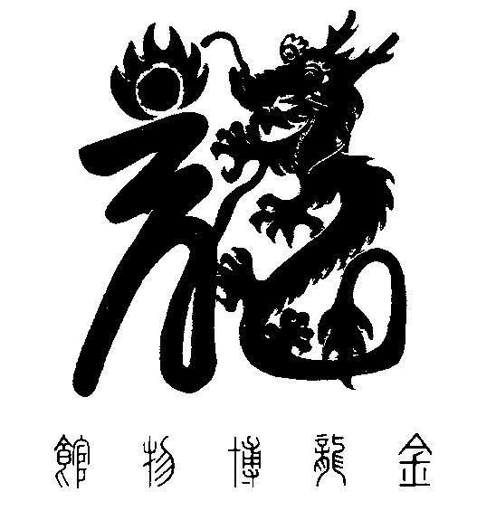

National Chinese Museum of Australia Ltd. T/A

**GOLDEN DRAGON MUSEUM**

**YI YUAN GARDENS & GUAN YIN TEMPLE**

Dai Gum San

1-11 Bridge Street Bendigo VIC 3550 / PO Box 877 Bendigo VIC 3552

**T** + 61 3 54 415044 / **E** info@goldendragonmuseum.org

**W** www.goldendragonmuseum.org

**ABN 41 309 670 936**

MEDIA RELEASE 18 November 2024

Memorial lecture shines new light on ancient customs.

**'The Year of the Dragon:**

**Depictions in Chinese Art'**

The Sylvia and Jeffory Mander Memorial Lecture 2024 will be presented by Luke Guan,

Head of Chinese and Asian Art, Leonard Joel.

**2.00 – 3.00pm Saturday 23 November**

**La Trobe Art Institute 121 View Street Bendigo**

In the midst of the Year of the Dragon, join Luke Guan and learn more about how the most auspicious of all creatures, the Dragon, has been depicted in Chinese art through the ages.

Luke Guan is the Head of the Chinese and Asian Art Department at Leonard Joel. He is also the director and chief valuer of L. Guan Asian Art. Luke has extensive experience across local and international auction houses, he has worked for several years as a specialist at the Chinese works of art department at Christie’s New York, and as an Asian art specialist at Mossgreen, Australia. He also served as a researcher and specialist at the world’s leading Chinese art gallery, Joyce Gallery, Hong Kong for several years prior to joining Mossgreen.  
  
Luke is an approved valuer for the Australian Government’s Cultural Gift Program and holds a Master of Letters (MLitt) degree in Chinese art history from the University of Glasgow and Christie’s Education.

The annual Sylvia and Jeffory Mander Memorial Lecture is held to recognise the significant contribution this local couple made as Museum volunteers over several decades. The Lecture is also an opportunity to recognise all the work and support our volunteers give us across the Museum's operations throughout the year.

Tickets available from Eventbrite

**Media enquiries: Hugo Leschen, Chief Executive Officer, Golden Dragon Museum 0417 100 229**

Image captions:

1. Luke Guan from Leonard Joel is presenting this year’s Sylvia and Jeffory Mander Memorial Lecture
2. A bronze wine vessel Zun, Shang Dynasty (13th -11th century B.C.E.)
3. A green jade carved ‘C’ shape dragon, Neolithic period (c.4700 – 2900 B.C.E.)